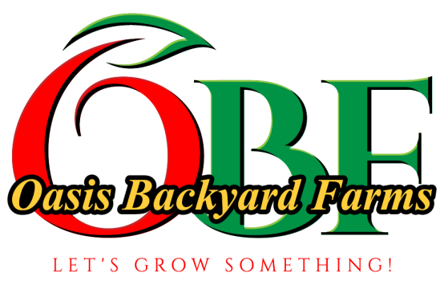
Oasis Backyard Farms
CSA Card Program
First Name___________________ Last Name____________________
Street Address________________________________________________
City_________________________ State_______ Zip____________
Home Phone__________________ Cell Phone____________________
Email address_____________________________________*
*Account status notifications and weekly produce availability updates are sent by email
________________________________________________________________________________________
Select Card Amount:
( ) $200 ( 6% DISCOUNT - Your season will start with $212 on your card)
( ) $250 ( 8% DISCOUNT - Your season will start with $270 on your card)
( ) $300 (10% DISCOUNT - Your season will start with $330 on your card)
( ) $400 (14% DISCOUNT - Your season will start with $456 on your card)
Contact us for Payment Options at...
info@oasisbackyardfarms.com
or
732.294.8703
________________________________________________________________________________________
I understand that I am making a commitment to Oasis Backyard Farms and recognize that there is no guarantee on the exact composition of the produce types that I may select from. Successful growing relies on the weather. I will share in the risks of the growing season with my farmer, and receive a discount from the market price as a reward. It is my responsibility to select produce to fully use the amount of my credit, with the understanding that my card has no expiration date and will roll over to the following season.
Oasis Backyard Farms understands that we are making a commitment to the CSA card holders of OBF to farm with the highest attention to quality, social responsibility, and sustainability. OBF produces only by sustainable and organic practices such as soil improvements, water conservation, wildlife protection and diverse plantings.

Signature___________________________________ Date_________________

